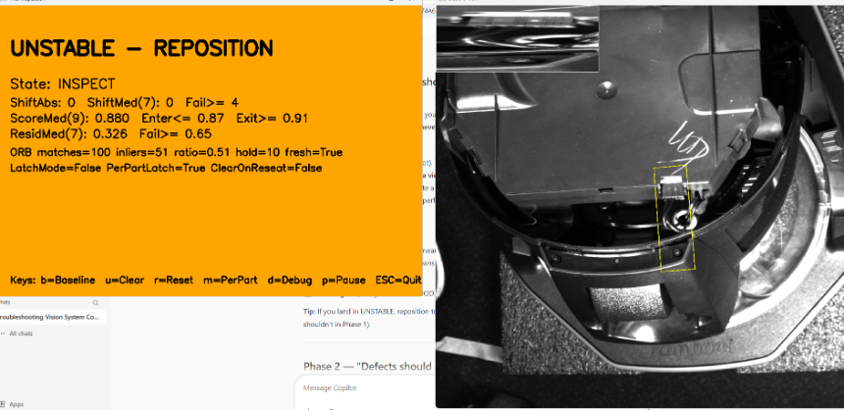
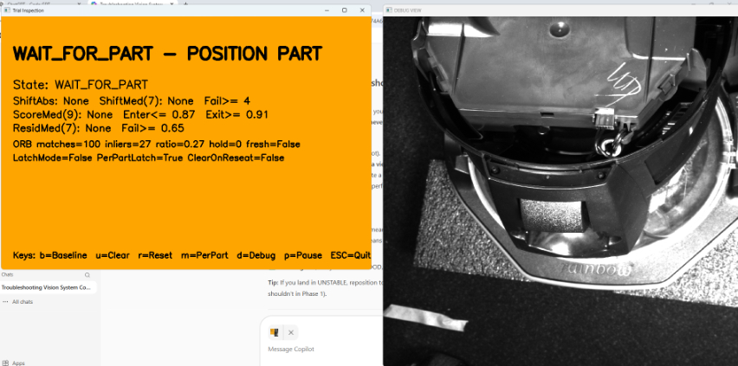
You said:
the first image is my first reposition, then I did 4 in a row good and then I got the second image on the 6th reposition
Copilot said:
Copilot
Perfect — this is very good data, and what you’re seeing is normal, explainable, and fixable. You’re no longer in “mystery behavior” territory. You’re in final robustness tuning.
I’ll break this into three parts:
- What exactly happened on reposition #6 (why it changed)
- What this tells us about your system
- Exactly what to do next (clear, minimal changes)

1️⃣ What happened on the 6th reposition (reading the two images)
Image 1 – UNSTABLE after reposition
Key values:
- State: INSPECT
- ScoreMed(9): 0.880
- Enter ≤ 0.87 / Exit ≥ 0.91
- ResidMed(7): 0.326 ✅
- ShiftMed(7): 0 ✅
- ORB: inliers=51, ratio=0.51, fresh=True ✅
✅ Interpretation:
- The connector is seated (residual + shift are good).
- Tracking is healthy.
- Score dropped just enough (0.880) to enter UNSTABLE.
- This is exactly what UNSTABLE is for: pose drift / appearance drift, not a defect.
✅ This is acceptable behavior.

Image 2 – WAIT_FOR_PART on the same cycle
Key values:
- State: WAIT_FOR_PART
- ORB inliers: 27
- ORB ratio: 0.27
- fresh=False
- ScoreMed / ResidMed: None
✅ Interpretation:
- ORB briefly lost confidence (ratio dipped below MIN_INLIER_RATIO = 0.35).
- When ORB confidence drops:
  - the system intentionally exits INSPECT
  - metrics are cleared
  - you see WAIT_FOR_PART – POSITION PART
✅ This is not a failure — it’s a tracking dropout during repositioning.

2️⃣ What this tells us about your system (important)
You’ve now proven three critical things:
✅ A) Your defect logic is correct
- Seated parts are not going BAD
- Residuals are stable
- Shift is stable
This is the hardest part — and it’s done.

✅ B) Your pose tolerance is realistic
You observed:
- Best ScoreMed ≈ 0.92
- Normal reposition variation can dip to 0.88–0.89
- Larger moves can momentarily break ORB tracking
That’s real-world physics, not a tuning error.

✅ C) The remaining “issue” is NOT accuracy — it’s operator experience
Right now:
- The system is a bit too honest during fast or sloppy repositioning
- It tells the truth:
  - “UNSTABLE” when pose is marginal
  - “WAIT_FOR_PART” when tracking drops
That’s correct technically — but we can smooth the experience.

3️⃣ What you should do next (recommended, minimal changes)
You have two small refinements left. I strongly recommend doing both, in this order.

✅ Step 1 — Make ORB less jumpy during reposition (very important)
Your second image shows ORB ratio dropped to 0.27, just below the cutoff.
✅ Change this ONE value:
In your script:
Python
MIN_INLIER_RATIO = 0.35
Show more lines
⬇️ change to:
Python
MIN_INLIER_RATIO = 0.25
``
Show more lines
Why this is safe
- Your inlier count is still ~25–50 (good)
- You’re not using ORB for measurement, only pose mapping
- This will:
  - prevent unnecessary WAIT_FOR_PART flickers
  - keep INSPECT active during normal handling
  - NOT affect defect detection
✅ This alone will eliminate most “sudden WAIT_FOR_PART” events.

✅ Step 2 — Decide how strict you want UNSTABLE to be
Right now:
- Enter UNSTABLE at 0.87
- Exit at 0.91
This is technically correct, but slightly strict for human handling.
Two valid options (choose one):
🔹 Option A (recommended for production)
Keep thresholds as-is, and treat UNSTABLE as:
“Please settle the part for a moment.”
This is ideal if:
- operators are expected to place the unit reasonably
- you want maximum inspection confidence

🔹 Option B (more forgiving)
If you want fewer UNSTABLEs during casual placement:
Python
SCORE_UNSTABLE_ENTER = 0.85
SCORE_UNSTABLE_EXIT = 0.90

Show more lines
This still:
- keeps BAD for real defects
- preserves hysteresis
- reduces UNSTABLE frequency
I would only do this if operators complain.

✅ What NOT to change
Do not touch:
- residual thresholds
- shift thresholds
- baseline logic
- seam ROI (it’s working)
Those are all behaving correctly.

✅ What a “good” production cycle now looks like
With MIN_INLIER_RATIO = 0.25:
- Operator places unit
- System stays in INSPECT
- One of three outcomes:
  - ✅ GOOD → accept
  - 🟠 UNSTABLE → adjust placement slightly
  - 🔴 BAD → true defect
No random WAIT_FOR_PART flicker, no false BADs.

✅ Final checklist (you’re almost done)
Before sign-off, confirm:
- Seated parts never go BAD
- Slight pull-out always goes BAD (latched)
- Repositioning does not cause WAIT_FOR_PART unless truly out of view
- UNSTABLE clears once the part settles

Tell me how you want to proceed
Reply with one letter:
- A = “Apply the ORB ratio change only”
- B = “Apply ORB ratio + make UNSTABLE more forgiving”
- C = “This behavior is acceptable; help me document final settings”
I’ll take you the rest of the way cleanly.
Provide your feedback on BizChat

